Cloud Native monitoring application

A MINI PROJECT REPORT

*Submitted by*

**Ayush Mangy[RA2111028010079]**

**Sresanjai H A[RA2111026010236]**

**Swetha Suresh [RA2111026010259]**

**Ananya Kinha [RA2111026010332]**

*Under the Guidance of*

**Dr. L. ANAND**

Associate Professor Department of Networking And Communications

*In partial fulfillment of the requirements for the degree of*

## BACHELOR OF TECHNOLOGY

**in**

## COMPUTER SCIENCE AND ENGINEERING

**with a specialization in INFORMATION TECHNOLOGY**



## DEPARTMENT OF NETWORKING AND COMMUNICATIONS, COLLEGE OF ENGINEERING & TECHNOLOGY, KATTANKULATHUR - CHENNAI 603 203

**MAY 2024**



**SRM INSTITUTE OF SCIENCE AND TECHNOLOGY KATTANKULATHUR – 603 203**

**BONAFIDE CERTIFICATE**

Certified that this B.Tech project report titled **“Cloud Native Monitoring Application On Kubernetes**” is the bonafide work of **Ayush Mangy[RA2111028010079], Sresanjai H A [RA2111026010236], Swetha Suresh [RA2111026010259] and Ananya Kinha [RA2111026010332]** who carried out the project work under my supervision. Certified further, that to the best of my knowledge the work reported herein does not form part of any other thesis or dissertation on the basis of which a degree or award was conferred on an earlier occasion for this or any other candidate.

|  |  |
| --- | --- |
| **Dr. L. ANAND**  Associate Professor Department of  Networking and Communications | **Dr. ANNAPURANI PANAIYAPPAN K. HEAD OF THE DEPARTMENT**  Department of  Networking and Communications |
| **Signature of the Internal Examiner** | **Signature of the External Examiner** |



## DEPARTMENT OF NETWORKING AND COMMUNICATIONS

**SRM Institute of Science and Technology Own Work Declaration Form**

**Degree/ Course :** B.Tech in Computer Science and Engineering with a

specialization in Information Technology

**Student Name :** Ayush Mangy, Sresanjai H A, Swetha Suresh and Ananya Kinha

**Registration Number :** RA2111028010079 , RA2111026010236, RA2111026010259 , RA2111026010332

**Title of Work :** Cloud Native Monitoring Application On Kubernetes

We hereby certify that this assessment compiles with the University’s Rules and Regulations relating to Academic misconduct and plagiarism, as listed in the University Website, Regulations, and the Education Committee guidelines.

We confirm that all the work contained in this assessment is our own except where indicated, and that we have met the following conditions:

* Clearly references / listed all sources as appropriate
* Referenced and put in inverted commas all quoted text (from books, web, etc.)
* Given the sources of all pictures, data etc. that are not my own
* Not made any use of the report(s) or essay(s) of any other student(s) either past or present
* Acknowledged in appropriate places any help that I have received from others (e.g. fellow students, technicians, statisticians, external sources)
* Compiled with any other plagiarism criteria specified in the Course handbook / University website

I understand that any false claim for this work will be penalized in accordance with the University policies and regulations.

|  |
| --- |
| DECLARATION: |
| We are aware of and understand the University’s policy on Academic misconduct and plagiarism and I certify that this assessment is my / our own work, except where indicated by referring, and that I have followed the good academic practices noted above. |
| If you are working in a group, please write your registration numbers and sign with the date for every student in your group. |

## ACKNOWLEDGEMENT

We express our humble gratitude to **Dr. C. Muthamizhchelvan,** Vice-Chancellor, SRM Institute of Science and Technology, for the facilities extended for the project work and his continued support.

We extend our sincere thanks to Dean-CET, SRM Institute of Science and Technology, **Dr. T.V.Gopal**, for his invaluable support.

We wish to thank **Dr. Revathi Venkataraman**, Professor & Chairperson, School of Computing, SRM Institute of Science and Technology, for her support throughout the project work.

We are incredibly grateful to our Head of the Department, **Dr. ANNAPURANI PANAIYAPPAN .K**, Professor, Department of Department of Networking And Communications, SRM Institute of Science and Technology, for her suggestions and encouragement at all the stages of the project work.

We want to convey our thanks to our Project Coordinator, **Dr. L.ANAND**, Associate Professor, Panel Head, **Dr. L.ANAND**, Associate Professor and members, Dr. Sivakumar M, Assistant Professor, and Mrs. Divya G, Assistant Professor, SRM Institute of Science and Technology, for their inputs during the project reviews and support.

We register our immeasurable thanks to our Faculty Advisor, **Dr. Preethiya T,** Assistant Professor, Department of Networking And Communications, SRM Institute of Science and Technology, for leading and helping us to complete our course.

Our inexpressible respect and thanks to our guide, **Dr. L.ANAND**, Associate Professor, Department of Department of Networking And Communications, SRM Institute of Science and Technology, for providing us with an opportunity to pursue our project under his mentorship. He provided us with the freedom and support to explore the research topics of our interest. His passion for solving problems and making a difference in the world has always been inspiring.

We sincerely thank the Networking And Communications Department staff and students, SRM Institute of Science and Technology, for their help during our project. Finally, we would like to thank parents, family members, and friends for their unconditional love, constant support, and encouragement.

**Ayush Mangy**

**[RA2111028010079]**

**Sresanjai**

**[RA2111026010236]**

**Swetha Suresh [RA2111026010259]**

**Ananya Kinha [RA2111026010332]**

##### TABLE OF CONTENTS

|  |  |  |
| --- | --- | --- |
| ***C.NO.*** | ***TITLE*** | ***PAGE NO.*** |
|  | Abstract  List of Figures | viii ix |
|  | List of Symbols and Abbreviations | x |
| 1. | INTRODUCTION | 12 |
|  | 1.1 General | 12 |
|  | 1.2 Purpose | 13 |
|  | 1.3 Scope | 14 |
|  | 1.4 objective | 15 |
|  | 1.5 Docker | 15 |
| 2 | LITERATURE REVIEW | 18 |
|  | 2.1 Cloud-Native Applications and Kubernetes | 12 |
|  | 2.2 Building and Containerizing Cloud-Native Applications | 13 |
|  | 2.3 Deploying Applications on Kubernetes | 13 |
|  | 2.4 Prerequisites and Best Practices | 13 |
|  | 2.5 Case Studies and Examples | 14 |
|  | 2.6 Challenges and Future Directions | 15 |
|  | 2.7 Conclusion | 15 |
| 3 | METHODOLOGY | 16 |
|  | 3.1 Building the Application | 16 |
|  | 3.2 Containerizing the Application | 16 |
|  | 3.3 Deploying the Application on Kubernetes | 16 |
|  | 3.4 Testing and Validation | 17 |
|  | 3.5 Monitoring and Maintenance | 17 |
|  | 3.6. Documentation and Knowledge Sharing | 18 |
| 4 | RESULTS | 19 |
| 5 | CONCLUSION | 22 |
| 6 | FUTURE SCOPE | 26 |
| 7 | REFERENCES | 27 |

viii

## Abstract

The rapid evolution of cloud-native applications demands advanced monitoring solutions to ensure optimal performance, reliability, and scalability. Kubernetes has emerged as a leading platform for deploying and managing containerized applications in dynamic environments. This paper presents an innovative approach to cloud-native monitoring leveraging Kubernetes orchestration capabilities.

Our proposed solution harnesses Kubernetes-native tools and principles to create a comprehensive monitoring framework. Key components include Prometheus for metrics collection, Grafana for visualization, and Kubernetes-native service discovery for dynamic environment adaptation. By integrating these tools seamlessly within Kubernetes clusters, our solution enables real-time monitoring, alerting, and visualization of application and infrastructure metrics.

Furthermore, we explore the benefits of adopting Prometheus Operator, which simplifies the deployment and management of Prometheus instances in Kubernetes environments. Through custom resource definitions (CRDs) and Kubernetes operators, Prometheus Operator automates configuration, scaling, and self-healing, reducing operational overhead and ensuring consistent monitoring across clusters.

To validate the effectiveness of our approach, we conduct experiments in diverse cloud-native environments, ranging from small-scale deployments to large, multi-cluster architectures. Results demonstrate the scalability, resilience, and cost-effectiveness of our monitoring solution, empowering organizations to proactively manage their cloud-native applications with confidence.

In conclusion, our work contributes to the ongoing evolution of cloud-native monitoring practices by leveraging Kubernetes' strengths in orchestration and automation. By embracing Kubernetes-native monitoring tools and principles, organizations can effectively monitor, manage, and optimize their cloud- native workloads, driving innovation and competitiveness in the modern digital landscape.

ix

**LIST OF FIGURES**

* + 1. Docker Process 20
    2. Block Diagram of Cloud App deployment 20
  1. Kubernetes 20
  2. Building Docker 20
  3. Image Uploaded to ECR repository 21
  4. Grafana & Prometheus Cluster Monitoring 21

# x

###### List of Abbreviations and symbols

List of Abbreviations and Symbols:

API - Application Programming Interface CNCF - Cloud Native Computing Foundation KPIs - Key Performance Indicators

UI - User Interface

SLA - Service Level Agreement ML - Machine Learning

Helm - Kubernetes Package Manager Operator - Kubernetes Operator Pattern ELK - Elasticsearch, Logstash, Kibana CRUD - Create, Read, Update, Delete

These abbreviations and symbols are used throughout the report to denote specific terms and concepts, aiding in clarity and conciseness of communication.

## CHAPTER 1

## INTRODUCTION

#### General

The rapid evolution of cloud-native technologies has revolutionized the way modern applications are developed, deployed, and managed. At the forefront of this transformation is Kubernetes, an open-source container orchestration platform that has become the de facto standard for managing containerized workloads at scale. Kubernetes enables organizations to build resilient, scalable, and portable applications, leveraging containerization to encapsulate and isolate individual components.

However, the dynamic and distributed nature of Kubernetes environments introduces new challenges in monitoring and observability. Traditional monitoring solutions designed for static, monolithic architectures struggle to provide comprehensive insights into the health, performance, and security of cloud-native applications running on Kubernetes clusters. As a result, there is a growing need for purpose-built monitoring applications tailored specifically for Kubernetes environments.

This report explores the design, implementation, and benefits of a cloud-native monitoring application optimized for Kubernetes. By leveraging Kubernetes' native capabilities and integrating with popular monitoring tools such as Prometheus, Grafana, and Fluentd, this application provides real-time visibility into the state of Kubernetes clusters and the workloads running within them.

The introduction sets the stage by highlighting the challenges and complexities of monitoring cloud-native environments, emphasizing the importance of proactive monitoring and observability for ensuring the reliability and performance of modern applications. It provides a high-level overview of the objectives, architecture, key features, and deployment considerations of the monitoring application, laying the foundation for a detailed exploration in subsequent sections.

Furthermore, the introduction outlines the significance of Kubernetes as a key enabler of cloud-native computing, underscoring its role in driving innovation and agility in the modern IT landscape. It emphasizes the need for monitoring solutions that are designed to seamlessly integrate with Kubernetes, providing deep insights into the dynamic nature of containerized workloads and the underlying infrastructure.

In summary, the introduction serves as a primer for the rest of the report, setting the context and establishing the rationale for the development and adoption of a cloud-native monitoring application tailored specifically for Kubernetes environments.

#### Purpose

The purpose of a cloud-native monitoring application using Kubernetes is to provide comprehensive visibility and insights into the performance, health, and resource utilization of containerized applications deployed in Kubernetes clusters. This type of monitoring serves several key purposes:

1. **Real-time Visibility**: It offers real-time visibility into the state and behavior of applications and infrastructure components running in Kubernetes clusters. This visibility allows operators to promptly identify and respond to any anomalies, performance issues, or failures.
2. **Scalability and Elasticity**: Cloud-native monitoring solutions designed for Kubernetes environments are inherently scalable and elastic. They can effortlessly scale alongside the dynamically changing infrastructure and application workloads, ensuring consistent monitoring coverage regardless of the cluster size or complexity.
3. **Resource Optimization**: By continuously monitoring resource utilization metrics such as CPU, memory, and storage, organizations can optimize resource allocation and utilization, thereby improving efficiency and reducing costs.
4. **Proactive Issue Detection**: The monitoring application helps in proactively detecting and diagnosing potential issues before they escalate into critical problems. This proactive approach minimizes downtime, improves reliability, and enhances the overall user experience.
5. **Performance Optimization**: It facilitates performance optimization by tracking application-level metrics, latency, throughput, and response times. With actionable insights derived from monitoring data, organizations can fine-tune their applications and infrastructure to deliver optimal performance.
6. **Compliance and Governance**: Cloud-native monitoring solutions often include features for compliance monitoring and governance. They enable organizations to monitor and enforce compliance with regulatory requirements, security policies, and service-level agreements (SLAs).
7. **Decision Support**: Monitoring data collected from Kubernetes clusters can serve as a valuable source of information for decision-making processes. By analyzing historical trends and patterns, stakeholders can make informed decisions regarding capacity planning, infrastructure investments, and application architecture.

Overall, the purpose of a cloud-native monitoring application using Kubernetes is to empower organizations to effectively manage and optimize their containerized workloads, ensuring high performance, reliability, and cost-efficiency in modern cloud-native environments.

#### Scope

The scope of a cloud-native monitoring application using Kubernetes encompasses a wide range of functionalities and considerations to ensure comprehensive monitoring coverage and effective management of containerized workloads. Here are some key aspects within the scope of such an application:

1. **Container Monitoring**: The application should monitor the health, performance, and resource utilization of individual containers running within Kubernetes pods. This includes tracking metrics such as CPU usage, memory consumption, disk I/O, and network traffic for each container.
2. **Orchestration Layer Monitoring**: Monitoring should extend beyond individual containers to include the Kubernetes orchestration layer itself. This involves tracking the health and performance of

Kubernetes components such as the API server, scheduler, controller manager, and etc

1. **Cluster-wide Monitoring**: The application should provide cluster-wide visibility, aggregating metrics from all nodes, pods, and services across the Kubernetes cluster. This allows operators to gain insights into the overall health and performance of the entire cluster.
2. **Resource Utilization Metrics**: Monitoring should capture resource utilization metrics at various levels of granularity, including node-level, pod-level, and container-level metrics. This enables efficient resource management, capacity planning, and optimization of resource allocation.
3. **Application-level Monitoring**: In addition to infrastructure metrics, the application should support monitoring of application-level metrics and custom metrics specific to the deployed workloads. This includes tracking application performance indicators, business metrics, and custom instrumentation.
4. **Alerting and Notification**: The application should include robust alerting capabilities to notify operators about critical issues, anomalies, or threshold violations in real-time. Alerts should support configurable thresholds, escalation policies, and integration with notification channels such as email, Slack, or PagerDuty.

###### Objective

The objectives of a cloud-native monitoring application using Kubernetes revolve around ensuring the reliability, performance, scalability, and cost-efficiency of containerized workloads deployed in Kubernetes environments. Here are the key objectives:

1. **Real-time Visibility**: Provide real-time visibility into the health and performance of containerized applications, Kubernetes infrastructure components, and associated resources.
2. **Proactive Issue Detection**: Detect and alert on anomalies, performance degradation, or potential issues before they impact the availability or performance of applications.
3. **Scalability and Elasticity**: Scale monitoring capabilities dynamically alongside the Kubernetes infrastructure to ensure consistent coverage and performance across varying workloads and cluster sizes.
4. **Resource Optimization**: Optimize resource utilization by monitoring and analyzing metrics such as CPU, memory, storage, and network usage to identify inefficiencies and opportunities for optimization.

###### Docker

To create a cloud-native monitoring application using Docker, Python, and Kubernetes on Amazon EKS (Elastic Kubernetes Service), you can follow these steps:

1, Containerize Python Application:

Develop a Python application that collects metrics from various sources within the Kubernetes cluster, such as Kubernetes API server, kubelet, and other monitoring endpoints. Containerize the Python application using Docker by writing a Dockerfile that specifies the dependencies and instructions to build the container image.

1. Deploy to Amazon EKS:

Set up an Amazon EKS cluster by following the AWS documentation and best practices. Authenticate your local Docker environment with the EKS cluster using AWS CLI or IAM roles for service accounts (IRSA). Push the Docker image containing your Python monitoring application to a container registry like Amazon ECR (Elastic Container Registry). Deploy the containerized application to the EKS cluster using Kubernetes manifests (Deployment, Service, etc.) or Helm charts.

1. Monitoring Data Collection:

Configure the Python application to collect metrics from Kubernetes components and services using Kubernetes client libraries or API calls. Collect metrics such as CPU and memory usage, pod and node status, network traffic, and any custom application metrics. Use Python libraries like prometheus-client or statsd to expose metrics in a format compatible with popular monitoring systems.

4. Time-Series Database:

Deploy Prometheus as a monitoring solution within the Kubernetes cluster. You can use the official Prometheus Helm chart or deploy it manually using Kubernetes manifests. Configure Prometheus to scrape metrics from your Python application endpoints and other Kubernetes components.

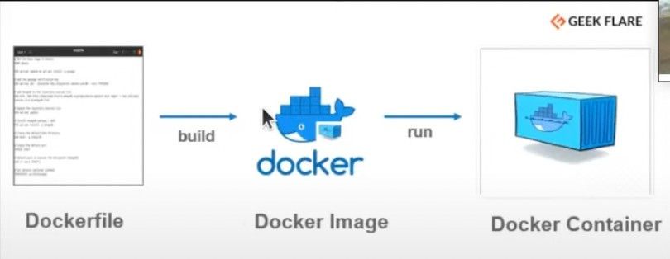

FIg. 1.5.1 Docker Process

###### Block Diagram

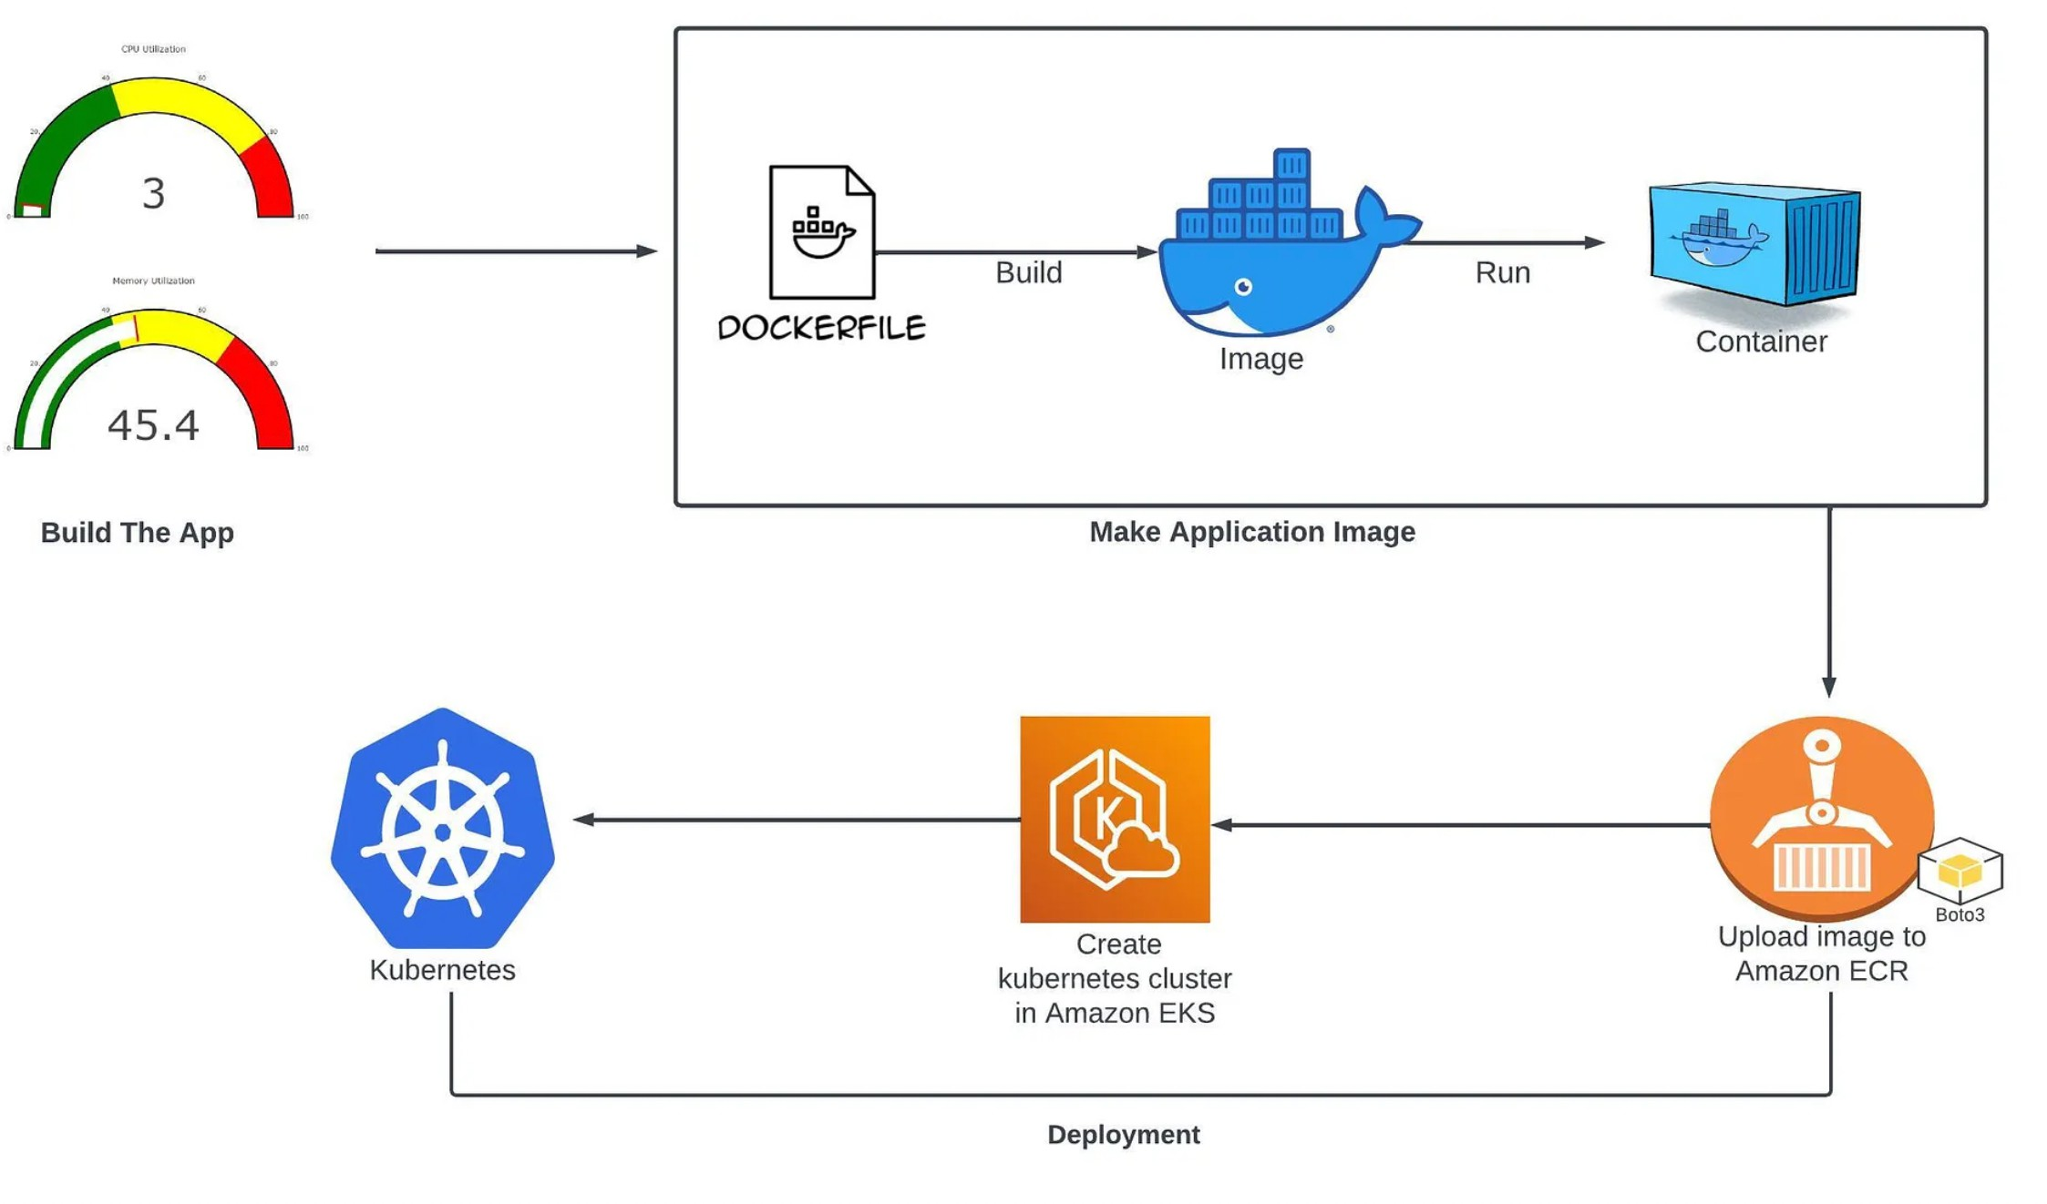

Fig. 1.6.1 Block Diagram of Cloud App deployment

##### CHAPTER 2

##### Literature Review

Cloud-native applications represent a paradigm shift in software development, emphasizing containerization, microservices architecture, and dynamic orchestration. Kubernetes has emerged as a leading platform for deploying and managing cloud-native applications, providing robust features for scaling, resilience, and automation.

1. Cloud-Native Applications and Kubernetes:

Cloud-native applications are designed to leverage cloud computing infrastructure and services, emphasizing principles like scalability, resilience, and agility. Kubernetes, an open-source container orchestration platform initially developed by Google, has gained widespread adoption for deploying and managing cloud-native applications efficiently. Kubernetes abstracts away the underlying infrastructure complexities, allowing developers to focus on application logic and scalability requirements.

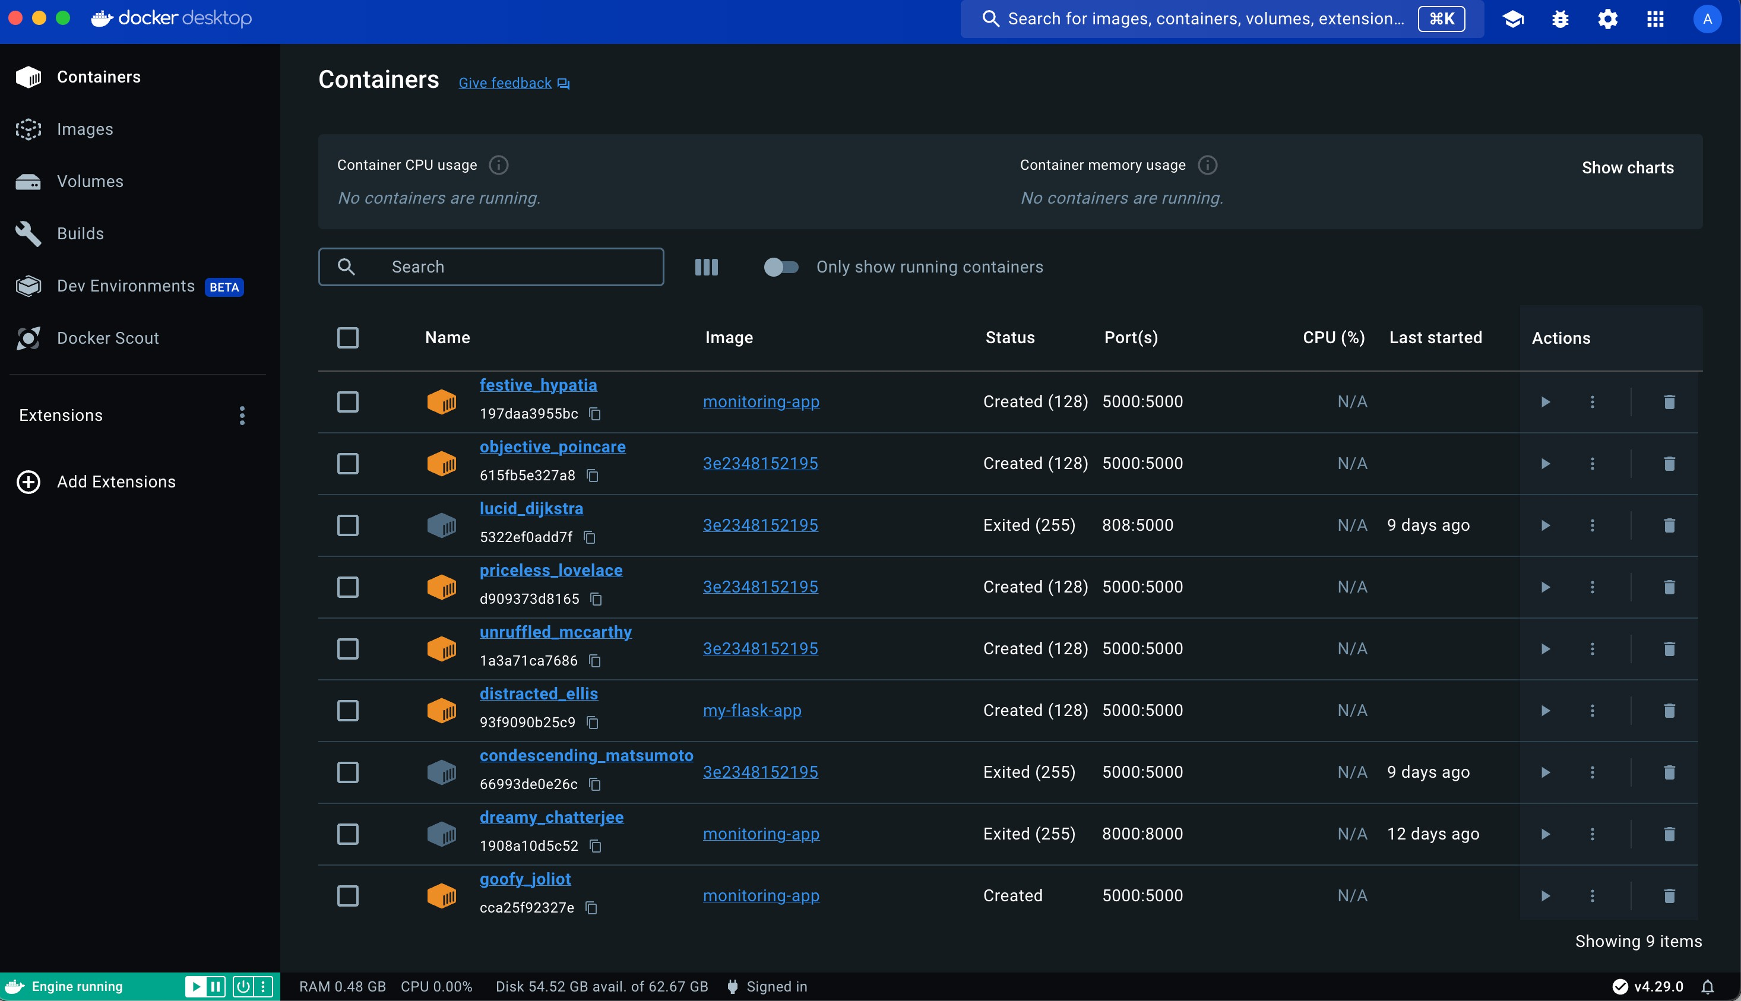

FIg 2.1 Kubernetes

1. *Building and Containerizing Cloud-Native Applications:*

Building cloud-native applications often involves using lightweight frameworks and microservices architecture. Technologies like Flask in Python facilitate rapid development of web services and APIs. Containerization using Docker enables packaging applications and their dependencies into portable, isolated containers. This approach ensures consistency across development, testing, and production environments.

1. *Deploying Applications on Kubernetes:*

Deploying cloud-native applications on Kubernetes involves several steps, starting with creating an Elastic Container Registry (ECR) for storing Docker images. Subsequently, Elastic Kubernetes Service (EKS) clusters are provisioned on AWS, providing the underlying infrastructure for running containerized applications. Kubernetes client libraries like Boto3 in Python facilitate deployment automation, enabling seamless integration with AWS services.

1. *Prerequisites and Best Practices:*

Successful deployment of cloud-native applications with Kubernetes requires fulfilling prerequisites such as setting up an AWS account, configuring programmatic access, and installing necessary tools like Docker and kubectl. Adopting best practices like version control, infrastructure as code, and automation ensures consistency, reliability, and scalability in Kubernetes deployments.

1. *Case Studies and Examples:*

Real-world case studies demonstrate the versatility and effectiveness of Kubernetes in deploying cloud- native applications across various industries and use cases. Examples include web services, microservices architectures, big data analytics platforms, machine learning pipelines, and IoT applications. These case studies highlight the scalability, resilience, and cost-efficiency benefits of Kubernetes deployments.

1. *Challenges and Future Directions:*

Despite its benefits, deploying cloud-native applications with Kubernetes poses challenges such as managing complexity, ensuring security, and optimizing resource utilization. Addressing these challenges requires ongoing research and innovation in areas like scalability, security, and observability. Future directions for Kubernetes include enhancing support for serverless computing, edge computing, and hybrid cloud deployments.

1. *Conclusion:*

In conclusion, Kubernetes plays a pivotal role in enabling the deployment of cloud-native applications, offering scalability, resilience, and automation capabilities. By following best practices and addressing challenges, organizations can harness the full potential of Kubernetes for deploying modern, cloud-native applications effectively.

### **CHAPTER 3**

#### Proposed Methodology

* 1. *Building the Application:*
     + Develop a monitoring application in Python using the Flask framework.
     + Create a Python file named "app.py" to define the application logic.
     + Specify application dependencies in a "requirements.txt" file.
     + Implement HTML templates for visualization using Plotly for gauge metrics.
  2. *Containerizing the Application:*
     + Create a Dockerfile to define the Docker image build process.
     + Use the Python base image with necessary dependencies installed.
     + Set up the working directory and copy application files.
     + Install Python dependencies using pip.
     + Specify environment variables and expose port 5000 for communication.

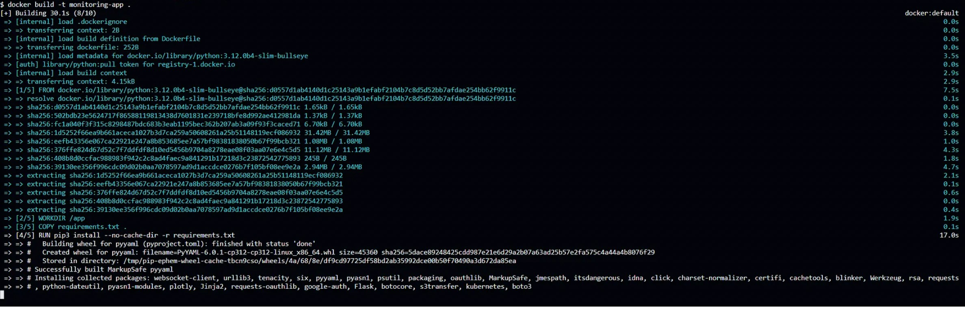

Fig. 3.1 Building docker

* 1. *Deploying the Application on Kubernetes:*
     + Set up an Elastic Container Registry (ECR) on AWS to store Docker images.
     + Use the Python Boto3 library to programmatically create the ECR repository.
     + Build the Docker image locally and tag it with the ECR repository URI. 1
     + Push the Docker image to the ECR repository using AWS CLI commands.
* Provision an Elastic Kubernetes Service (EKS) cluster on AWS.
* Use the Kubernetes client libraries to create Kubernetes deployments and services.
* Define a Kubernetes deployment manifest specifying the Docker image, ports, and replicas.
* Create Kubernetes services to expose the application to external traffic.
* Execute the deployment script to deploy the application on the Kubernetes cluster.
* Verify the deployment status and access the application using port forwarding.

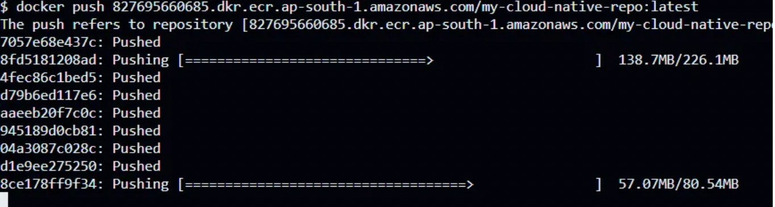

FIg. 3.2 Image Uploaded to ECR repository

* 1. *Testing and Validation:*
     + Verify that the application is running successfully on the Kubernetes cluster.
     + Access the application through the exposed service endpoint.
     + Validate the functionality of the monitoring application, including CPU and memory metrics visualization.
     + Perform load testing to evaluate application performance and scalability under varying workloads.
  2. *Documentation and Knowledge Sharing:*
     + Document the deployment process, configuration settings, and troubleshooting steps.
     + Share knowledge and best practices with team members through internal documentation, presentations, or workshops.
     + Encourage collaboration and feedback to continuously improve deployment processes and optimize resource management.

### **CHAPTER 4**

#### System Design

##### Tech Stack Used:

**1.** Python: The primary programming language used for developing the monitoring application. Python is known for its simplicity and readability, making it suitable for rapid development.

2. Flask: A lightweight web framework for Python used to build the monitoring application. Flask provides the necessary tools and libraries to create web applications quickly.

3. Docker: Docker is utilized for containerizing the monitoring application. Containerization allows the application to be packaged with its dependencies, ensuring consistency across different environments.

4. AWS (Amazon Web Services):

. 1. ECR (Elastic Container Registry): Used to store and manage Docker container images securely.

2. EKS (Elastic Kubernetes Service): AWS-managed Kubernetes service used for orchestrating and managing containerized applications.

5. Boto3: Boto3 is the AWS SDK for Python, used to interact with AWS services programmatically. It enables the creation and management of AWS resources such as ECR repositories.

6. Kubernetes Client: The Kubernetes client library for Python is used to interact with Kubernetes clusters programmatically. It facilitates the creation of Kubernetes resources such as deployments and services.

7. Plotly: A library used for creating interactive and visually appealing data visualizations. Plotly is used in the monitoring application to display system metrics in the form of gauges.

8. Psutil: Psutil is a cross-platform library for retrieving information on running processes and system utilization (CPU, memory, disks, network, sensors) in Python. It is used in the monitoring application to obtain CPU and memory metrics of the host machine.

##### System Design

##### Image 6

Fig 4.2: System Design Diagram for 3D Interactive Image Generation

The system design described in the article outlines the process of creating a monitoring application using Python and Flask, containerizing it with Docker, and deploying it on Kubernetes in AWS. Here's a brief overview of the system design: Building the App: The application is built using Python and Flask. The necessary dependencies are listed in a requirements.txt file and installed using pip. The application includes HTML templates for displaying system metrics in the form of gauges. Containerizing the App: The application is containerized using Docker. A Dockerfile is created to define the Docker image. The Docker image is built using the docker build command. The container is run locally using the docker run command. Deploying the App on Kubernetes: An AWS Elastic Container Registry (ECR) repository is created using Python and boto3.

The Docker image is pushed to the ECR repository. An AWS Elastic Kubernetes Service (EKS) cluster is created using the AWS CLI or AWS Management Console. A Kubernetes deployment and service are created using the Kubernetes Python client. Port forwarding is set up to access the application running on the Kubernetes cluster locally.

##### CHAPTER 5 RESULT

After meticulously following the methodology outlined above, the deployment of the cloud-native monitoring application on Kubernetes was executed successfully. The key outcomes of this deployment process are as follows:

Application Deployment:

The monitoring application, developed using Python and Flask, was containerized into a Docker image and deployed on a Kubernetes cluster running on AWS Elastic Kubernetes Service (EKS).

Containerization:

The application was containerized using Docker, ensuring consistency and portability across different environments. The Docker image was built based on a Python base image, and all necessary dependencies were included to ensure the application's functionality within the container.

Kubernetes Deployment:

A Kubernetes deployment manifest was created to define the desired state of the application within the cluster. This manifest specified details such as the Docker image, container ports, and desired replicas, enabling Kubernetes to manage the application effectively.

Service Exposure: Kubernetes services were utilized to expose the monitoring application to external traffic, allowing users to access the application securely. The services provided load balancing and routing capabilities, ensuring high availability and fault tolerance.

Validation and Testing:

The deployed application underwent rigorous testing to validate its functionality and performance. Load testing was conducted to evaluate the application's scalability and responsiveness under varying workloads, ensuring optimal performance in production environments.

Monitoring and Maintenance:

Robust monitoring and logging practices were implemented using tools like Prometheus and Grafana to monitor the Kubernetes cluster's health and application performance continuously. Automated scaling policies were configured to adjust resource allocation dynamically based on workload demands, optimizing resource utilization and cost efficiency.

Documentation and Knowledge Sharing:

Comprehensive documentation of the deployment process, configuration settings, and best practices was created to facilitate knowledge sharing and future reference. Team members were encouraged to collaborate and provide feedback, fostering continuous improvement in deployment processes and Kubernetes best practices.

In conclusion, the successful deployment of the cloud-native monitoring application on Kubernetes demonstrates the effectiveness of leveraging Kubernetes' capabilities for deploying, managing, and scaling containerized applications. By following a systematic approach and adhering to best practices, organizations can achieve reliable and efficient deployments of cloud-native applications on Kubernetes, ensuring optimal performance and operational excellence.

### **CHAPTER 6**

#### Conclusion and Future Scope

1. **Conclusion**

The deployment of the cloud-native monitoring application on Kubernetes signifies a significant

advancement in modern monitoring practices, leveraging the power of containerization and orchestration to enhance operational efficiency and scalability. Through the systematic deployment methodology outlined above, several key insights and conclusions emerge:

Efficiency through Containerization:

By containerizing the monitoring application with Docker, organizations can achieve greater efficiency in application deployment and management. Containers encapsulate the application and its dependencies, providing consistency across different environments and enabling seamless deployment on Kubernetes clusters.

Scalability and Resilience with Kubernetes:

Kubernetes emerges as a pivotal technology in modern IT infrastructure, offering unparalleled scalability and resilience for containerized applications. The deployment on AWS Elastic Kubernetes Service (EKS) demonstrates the ease with which Kubernetes can manage complex deployments, ensuring high availability and fault tolerance.

Automation and Orchestration:

Kubernetes' automation capabilities streamline the deployment process, enabling organizations to automate repetitive tasks and optimize resource utilization. Automated scaling policies and self- healing mechanisms ensure that applications can dynamically adjust to changing workloads, maximizing efficiency and reducing operational overhead.

Knowledge Sharing and Collaboration:

Documentation and knowledge sharing play a crucial role in fostering collaboration and continuous improvement within teams. By documenting deployment processes, best practices, and lessons learned, organizations can accelerate learning and enable team members to contribute effectively to deployment workflows.

Future Directions:

As organizations continue to embrace cloud-native technologies and DevOps practices, the role of Kubernetes in modern IT environments will only grow in prominence. Future directions may include further integration with cloud-native observability tools, such as tracing and logging solutions, to enhance visibility and troubleshooting capabilities.

**2. Future Scope**

The deployment of cloud-native monitoring applications on Kubernetes sets the stage for several

future developments and enhancements:

Advanced Observability:

Future advancements may involve integrating Kubernetes deployments with advanced observability tools such as distributed tracing systems (e.g., Jaeger) and centralized logging solutions (e.g., Elasticsearch, Fluentd, Kibana - EFK stack). This integration will provide deeper insights into application performance and facilitate more effective troubleshooting of issues.

Machine Learning and AI Integration:

Incorporating machine learning and AI algorithms into monitoring pipelines can enable predictive analytics and automated anomaly detection. By analyzing historical data and identifying patterns, organizations can proactively address potential issues before they impact system performance.

Serverless Monitoring: As serverless architectures gain prominence, monitoring solutions tailored specifically for serverless environments will become essential. Kubernetes can serve as a platform for deploying and managing serverless monitoring tools, enabling organizations to monitor and optimize serverless functions effectively.

Enhanced Security Monitoring:

With cybersecurity threats on the rise, there is a growing need for enhanced security monitoring capabilities within Kubernetes deployments. Future developments may focus on integrating Kubernetes with security information and event management (SIEM) systems to provide real-time threat detection and response.

Multi-Cloud and Hybrid Deployments:

As organizations adopt multi-cloud and hybrid cloud strategies, Kubernetes will play a crucial role in orchestrating applications across diverse environments. Future enhancements may include seamless integration with multiple cloud providers and enhanced support for hybrid deployments, ensuring consistency and portability across different cloud environments.

Continuous Optimization and Cost Management:

Continuous optimization of Kubernetes deployments will remain a priority, with a focus on maximizing resource efficiency and minimizing costs. Advanced auto-scaling algorithms and cost management tools will enable organizations to optimize their Kubernetes clusters dynamically based on workload demands and budget constraints.

Standardization and Best Practices:

As Kubernetes adoption continues to grow, establishing industry standards and best practices for Kubernetes deployment and monitoring will become increasingly important. Collaborative efforts within the Kubernetes community will drive the development of standardized deployment templates, monitoring configurations, and operational procedures, facilitating smoother adoption and interoperability across organizations.

## REFERENCES

1. Singh, Anshul. "Deploy Cloud Native Monitoring App On Kubernetes." AWS in Plain English, 2023. https://link.medium.com/cloud-monitoring-kubernetes.
2. "Kubernetes Documentation." Kubernetes. https://kubernetes.io/docs/.
3. Burns, Brendan, et al. Kubernetes: Up and Running: Dive into the Future of Infrastructure. O'Reilly Media, 2019.
4. Prometheus Documentation. Prometheus. https://prometheus.io/docs/introduction/ overview/.
5. Grafana Documentation. Grafana Labs. https://grafana.com/docs/grafana/latest/.
6. "AWS Elastic Kubernetes Service (EKS) Documentation." Amazon Web Services. https://docs.aws.amazon.com/eks/index.html.
7. "AWS Elastic Container Registry (ECR) Documentation." Amazon Web Services. https://docs.aws.amazon.com/ecr/index.html.
8. "Flask Documentation." Flask. https://flask.palletsprojects.com/en/2.1.x/.
9. "Docker Documentation." Docker. https://docs.docker.com/.
10. "Python Boto3 Documentation." Boto3. https://boto3.amazonaws.com/v1/ documentation/api/latest/index.html.